# Merchant Creation Workflow

## List of Merchants Pending for Review

The first step will be to check for merchants pending for review. The way it should work is once a Sales Representative creates a merchant in SalesForce (clients that fill our form, not leads) and the feeding from SalesForce to the new system occurs, we should see a list of the created Merchants that have not been reviewed. Then we select one of those Merchants and start the review process. Once this process starts, the system should assign an ID number to the new merchant. For example, the first merchant will be ID 1, the second ID 2, and so on, unless the Merchant is being recreated for reevaluation purposes, in which case it will keep the ID that was assigned to it the first time it was created.

We also need the option to do this step manually. That is by manually adding a Merchant to the list, and every field that requires information from SalesForce will be filled manually.

## Document Scanning

The second step is the Document Scanning, here we should be able to scan any document we have, but the only required document will be the Application Form, which we should be able to upload in PDF or any image format (it should allow us to scan PDFs, docs, xlsx, and any image file):

Our current Doc Scan screen looks like this (my notes in red):

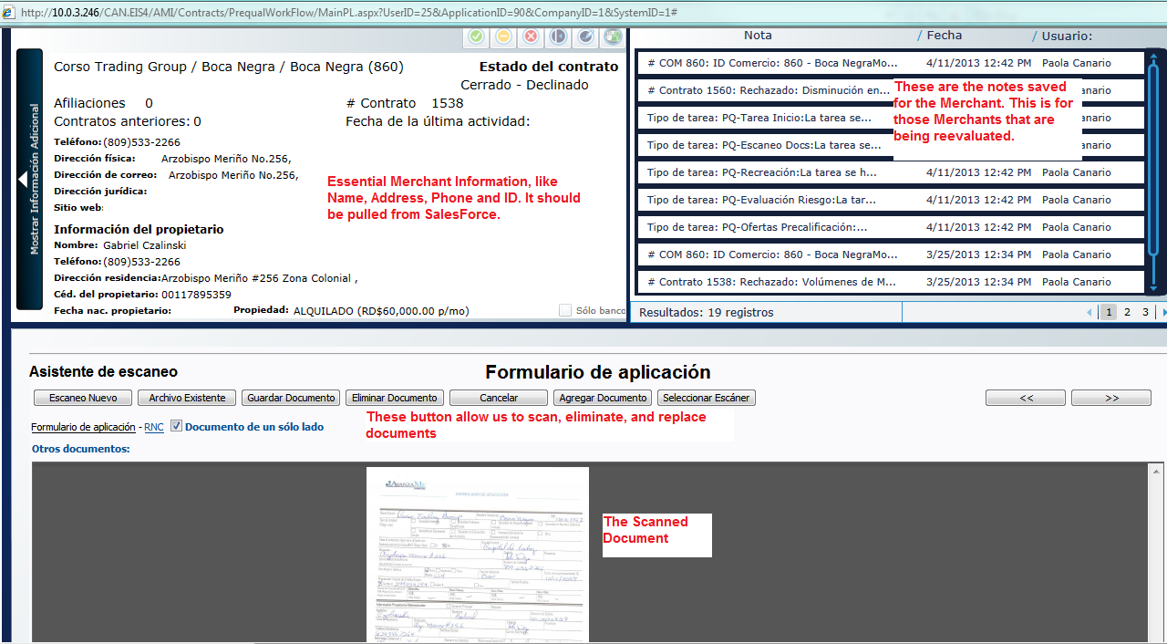

## Data Entry

The third step is the data entry. All this information should be filled from SalesForce, but we should be able to modify anything, in case we have to. The information we should have here is:

* Name of the Company
* Name of the Business
* RNC: This is the ID the government assigns to every company. It should have a maximum of 11 numbers.
* Address
* City
* Province: This should be a drop down list with the following options:
* Azua
* Bahoruco
* Barahona
* Dajabón
* Duarte
* Elías Piña
* El Seibo
* Espaillat
* Hato Mayor
* Independencia
* La Altagracia
* La Romana
* La Vega
* María Trinidad Sánchez
* Monseñor Nouel
* Montecristi
* Monte Plata
* Pedernales
* Peravia
* Puerto Plata
* Hermanas Mirabal
* Samaná
* Sánchez Ramírez
* San Cristóbal
* San José de Ocoa
* San Juan
* San Pedro de Macorís
* Santiago
* Santiago Rodríguez
* Santo Domingo
* Valverde
* Distrito Nacional
* Telephone Number: Dominican telephone numbers have 10 digits in the format: (xxx) xxx-xxxx.
* Email
* Industry Type: We will annex all the options that will make up this drop list. This comes from the predetermined MCC codes.
* Type of Property: This should be a drop down list with two options, Owned and Rented.
* Rent Amount: This should be a currency field.
* Gross Yearly Sales: This should be a currency field.
* Processor Company: Either CardNet or VisaNet.
* Affiliate Number: The affiliate number for the business with either CardNet or VisaNet (or both). We should be able to add more than one affiliate number.

Then we should have the Owner’s Information in the same screen:

* Name
* Last Name
* ID or Passport Number: A maximum of 11 characters, either numbers or letters.
* Phone Number
* Cell Phone Number: In the format (xxx) xxx-xxxx.
* Address
* Email

Then we should have CardNet’s and VisaNet’s information:

* Name of the Company
* RNC
* Bank Account number
* Bank Account Name
* Authorized Owner

These fields will be filled from the SPF files and we need them to compare our information with the information CardNet and VisaNet have in their system.

Our current Data Entry Screen looks like this:

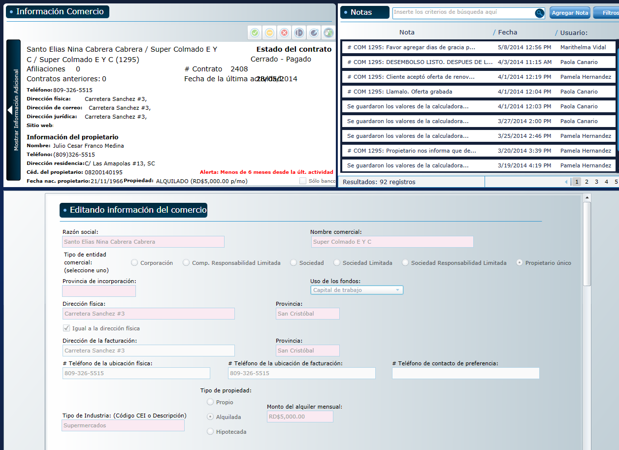

As you can see, the top part is very similar to the Doc Scan screen, and bellow is all the information I have indicated above.

## Credit Card Volumes

At this point the system should send a request to VisaNet and CardNet for the credit card volumes, then, once we receive the request, the workflow continues. There are times when we receive the volumes outside the normal process, through email or some other way, which is why we need to have the option, in our system, to manually type the credit card volumes, so that it can go on to the scoring job.

Once the Merchant is created, the system will automatically send a Request through an MRF file to the Credit Card Processor Company. This MRF file contains the Date of the Request, the ID of the Merchant in our System, the Merchant’s affiliate number with the Processor and the Company ID.

Also, at this point we would like the system to automatically send the physical Form we scanned earlier to CardNet (but not to VisaNet), perhaps through the same way we will send the Volumes request. (This is something we will work out in detail later)

Here is an example of an MRF file:

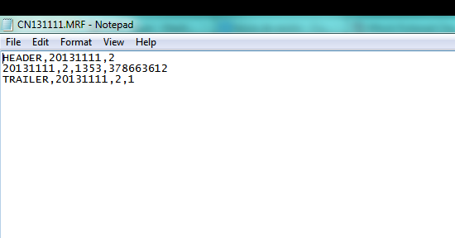

The Processor Company will respond with an SPF file containing the monthly credit card volumes of the merchant requested. Here is an example of an SPF file:

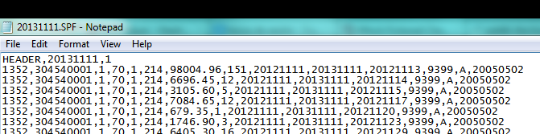

## Scoring Job, Merchant Evaluation

After we have received the Credit Card Volumes through the SPF file or manually introduced, the new task is going to be the Merchant Evaluation task. Here our officer will generate the score for the Merchant, take a look at the Datacrédito and the Credit Card volumes, and then decide whether to go to the Offer Creation task or decline the Prequalification.

Every Datacrédito report we pull should be saved as a Document in the Merchant. And we should have a list of every Datacrédito report we have ever pulled for the Merchant and be able to access them at any time.

## Offer Creation

Here we create the offers. One Merchant could have any number of offers saved. To create the offer we use a Calculator Application.

This is how the calculator currently looks:

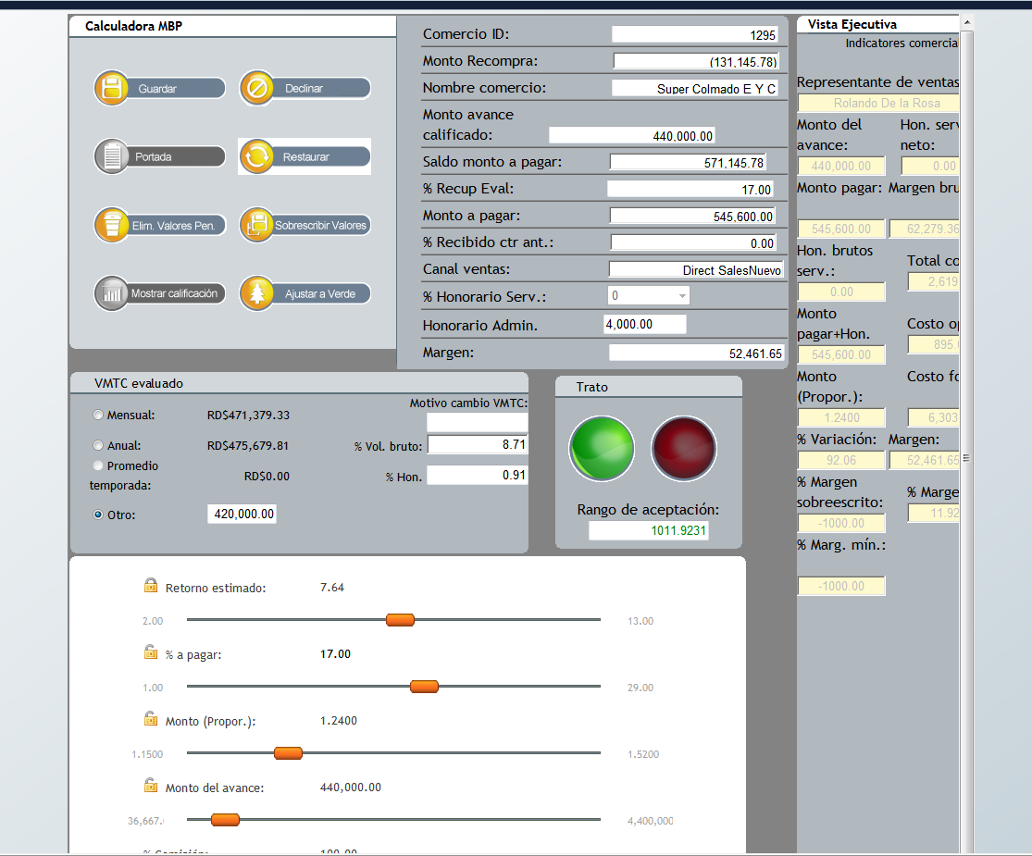

This is an idea of what it could look like (simplified):



This should pull the Gross Yearly Sales automatically from the information entered in the Merchant Creations process, but it should let us change it manually in case we need to. The Average Monthly Credit Card Sales should be calculated from the volumes. It should also let us change in manually if we need to.

This is the Offer Calculator. The components of the offer are the Time in months the contract is expected to last, the loaned and owed amount, the proportion (This is the Owed Amount divided by the Loaned Amount, for example, if the loan is going to be 100, and the owed amount will be 150, then the proportion is 1.5) and the retention percentage, which is the fixed percentage we will be discounting from the credit card sales of the Merchant as payment. Every field should have sliders to move around the amounts until the officer is comfortable with the offer.

This button is to save the current offer, so that the officer can do more than one offer to present the client.

Here it should display all the saved offers and the details of the offers.

Once the officer has saved all the offers he needs to, he can hit complete or decline (as usual). If he hits complete, then the system should generate a PDF file with all the saved offers and the details. This is the file the officer is going to send the Sales Representatives so that they can present them to the client. At the same time, it should send an email to the Sales Rep in the following format:

ID # XXX: Merchant Name

Sales Representative Name: John Doe

Business Owner Name: Jack Doe

Offer Date: DD/MM/YY

Expiration Date: DD/MM/YY

Offers

Offer 1

MCA Amount: RD$104,000.00

Owen Amount: RD$127,920.00

Price: 1.2300

% Retention: 29.00%

Repayment Time (months): 5.03

Pending Requirements:

Additional Notes:

## 8. Offers Pending for Acceptance

This should be another list where we have all the pending offers with the option to accept any offer and kick off the contract workflow. If the offer is declined, the Agent will choose any of the decline reasons and the Merchant will be marked as declined, with the possibility of reactivation within a 60 day window. If the contract has not been reactivated after 60 days, then the Merchant must be recreated in the usual way.

Every pending offer has an expiration time of 30 days. If after the 30 days have passed, the offer has not been neither declined nor accepted, it will be marked as expired and no longer valid.

We need to be able to edit any Offer parameter before accepting it and, once it’s been accepted, the system should automatically send an email with the accepted offer to the Sales Rep and Management people we will indicate at a later time.

## Additional Information

Every step of the work flow should have the following buttons on the top:

* **Complete Button**: This is the button that we will click once we are ready to complete the task and move on to the next task.
* **Decline Button**: This is the button that we will click if we want to decline the Merchant at any point in the process. It will ask the user to specify the Decline reason, which will come from the following list:

**Declined By Avanzame**:

* Unacceptable Credit Score
* Merchant doesn’t fulfill Gross Yearly Sales requirement
* Merchant doesn’t have authorized Credit Card Processor
* Merchant doesn’t fulfill minimum CC transactions requirement
* CC sales have gone down
* Less than 5 months accepting CC payments
* CC volumes don’t fulfill requirements
* The person who signed the form is not an authorized person
* The Merchant has already been created by another Rep
* Merchant stopped processing.

**Declined By the Client:**

* The client doesn’t want a loan at this time
* The client declines because of the Administrative Expenses
* The client declines because of the price
* The client declines because of the Retention Percentage
* The client wants a bigger loan
* The client wants a higher repayment time
* The client is unreachable / refuses to return calls
* The client refuses to present required documents
* Merchant has different financing option

* **Kick Back Button**: This is the button that we will click if we want to kick back the Merchant from a task to a previous task of choosing.
* **Notes Button**: This button should open the Notes application that will let us save any note or comment to the Merchant.
* **Documents Button**: This button should open a popup that will let us display any document that has been scanned and saved to the Merchant. We need to have this because sometimes our Agent needs to verify some information with the physical form.

**IMPORTANT: You need to keep in mind that although everything here is English, we work in Spanish, so every field will have to be translated into Spanish eventually.**

**IMPORTANT: All the data and offers should be fed back and forth between the system and SalesForce so that at the end of the day, both systems have the same information regarding Merchant, Offers and everything else.**